Table of Contents
1. Introduction
1.1 Purpose
1.2 Document Conventions
1.3 Intended Audience and Reading Suggestions
1.4 Project Scope
1.5 References
2. Overall Description
2.1 Product Perspective
2.2 Product Features
2.3 User Classes and Characteristics
2.4 Operating Environment
2.5 Design and Implementation Constraints
2.6 Assumptions and Dependencies
3. System Features
4. External Interface Requirements
4.1 User Interfaces
4.2 Hardware Interfaces
4.3 Software Interfaces
4.4 Communications Interfaces
5. Other Nonfunctional Requirements
5.1 Performance Requirements
5.2 Safety Requirements
5.3 Security Requirements
5.4 Software Quality Attributes
1. INTRODUCTION
1.1 PURPOSE
The purpose of this document is to provide the software requirement specification report for the E – HEALTHIFY SYSTEM.
1.2 DOCUMENT CONVENTIONS
DB | Data base
DDB | Distributed Data base
ER | Entity relationship
1.3 INTENDED AUDIENCE AND READING SUGGESTIONS
This project is the college level project and is implementing under the guidance of college professors. This project is useful to those who want to lose their weight and be fit and healthy from home.
1.4 PROJECT SCOPE
It’s health and fitness application. E–Healthify system redefines fitness lifestyle through digital communication. One can use this system in order to maintain their health and fitness.
1.5 REFRENCES
- www.krazytech.com/projects
- fundamental of database systems by ramez elmarsi and shamkant b.navathe
- www.healthifyme.com
2. OVERALL DESCRIPTION
2.1 PRODUCT PERSPECTIVE
A distributed calorie and intake, also user database stores the following information as shown below.
- USER DESCRIPTION:
It includes username , height , weight , age , gender , blood group and nature of work . This infomation may be used for keeping the records of user for any other kind of information.
- FITNESS AND DIET DESCRIPTION:
It includes details of intake, calorie information for each item.
- For fitness, workout plans like Yoga, Jazz, Aerobics, Zumba and some simple exercises.
- Diet plans are provided separately for breakfast, lunch and dinner.

2.2 PRODUCT FEATURES
The major features of E–Healthify system are shown in below Schema diagram.

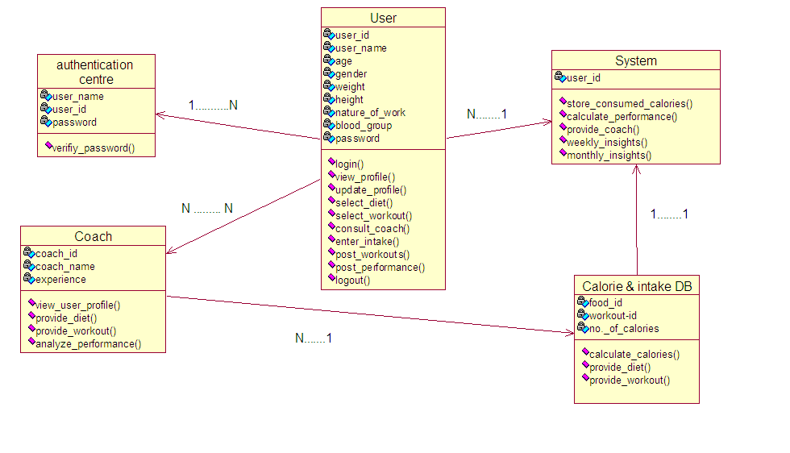

Layout of e-healthify system  class diagam
2.3 USER CLASS AND CHARACTERISTICS
Users of the system should be able to maintain their health and fitness. The information like height, weight, gender, age and their nature of work etc. must be provided by the users. Users get proper guidance about what to consume daily and what exercises do they need to perform to be fit. Calorie information will be calculated based on the food they consumed and everything will be stored in an database. Users are provided with the Diet and Fitness Coach. There are two different kinds of coaches that is paid and unpaid. For consultation users can chat with the coach and they call using the toll-free numbers given. This e-healthify system will have a platform where users can post their workouts and diet daily, like a user interactive blog. All the records of the users are stored in a database and their performances are measured on monthly and weekly basis. The user should be able to do the following functions:
- Provide their proper information about intake.
o Breakfast
o Lunch
o Dinner
o Snacks and any beverages
- Chat & make calls to the Diet and Fitness Coach.
- Can select proper workout and diet plans.
- View his performance on weekly and monthly basis.
- Post their daily workouts.
- SYSTEM FUNCTIONS.
o Get all users information and also allow updation.
o Get all calorie information for a given intake.
o View diet plans and workout plans.
o Provide diet and fitness coach for consultation.
o Calculate performance growth for each user on weakly and monthly basis.
- ADMINISTRATIVE
o Add different kind of diets.
o Add different kind of workouts and exercises.
o Update user calorie consumption daily.
o Calculate the performance growth of each user.
o Update user personal details ( like height, weight) etc. if they are required.
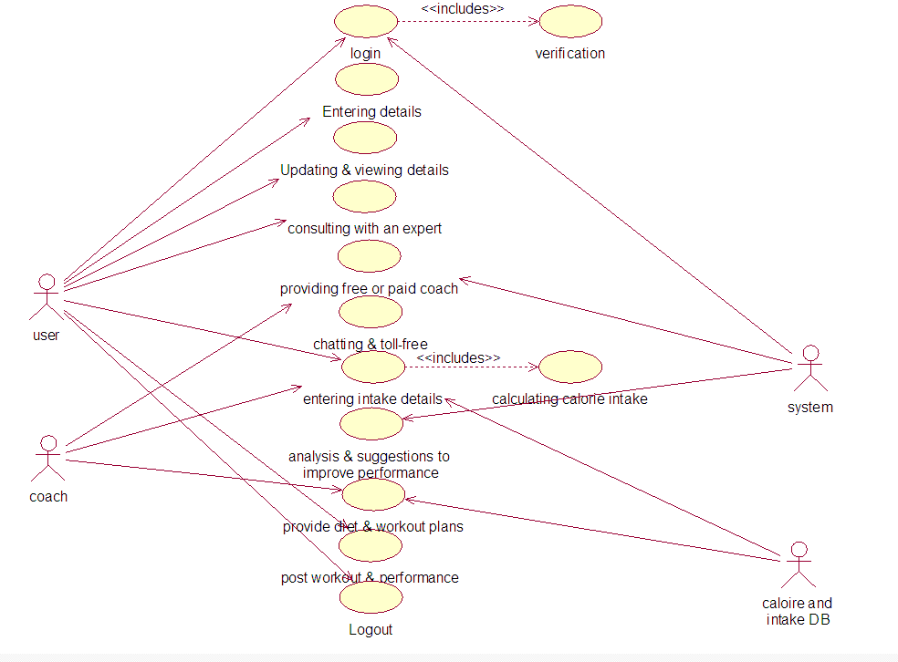

Use case diagram for E-Healthify System.
2.4 OPERATING ENVIRONMENT
Operating environment for the E-Healthify system is as listed below.
- distributed database
- client/server system
- operating system : windows xp.
- database: sql+ database
- platform: vb.net
2.5 DESIGN AND IMPLEMENTATION CONSTRAINTS
i) The global schema, fragmentation schema, allocation schema.
ii) SQL commands for above queries/applications
iii) How the response for application 1 and 2 will be generated. Assuming these are global queries. Explain how various fragments will be combined to do so.
iv) Implement the database at least using a centralized database management system.
2.6 ASSUMPTION DEPENDENCIES
Let us assume that this is a distributed calorie and intake database and it is used in the following application:
- Provide a perfect diet and fitness plan for the particular user which is well suitable to him/her , using information from a database.
- Calculation of calories consumed by the user in a particular day and their performance growth.
We have designed a distributed database that is practically dispersed for four kind of diet plans like breakfast, lunch, dinner and any kind of snacks and beverages.
3. SYSTEM FEATURES
- DESCRIPTION AND PRIORITY
The e-healthify system help a person maintain health and fitness, provide information about calories to be consumed and workouts to be performed.
Of course this project has high priority because there is a need for the people to become fit and healthy with each passing day.
- STIMULUS/RESPONSE SEQUENCES
  - Search for diet plan and workout plan.
  - List the different diet plans for breakfast, lunch, dinner etc.
  - List different kind of workout plans.
  - Displays a detailed performance of each person on monthly and weekly basis.
  - Users posting their performance growths.

- FUNCTIONAL REQUIREMENTS
  - DISTRIBUTED DATABASE:
Distributed database implies that a single application should be able to operate transparently on data that is spread across a variety of different databases and connected by a communication network as shown in below figure.

Distributed database located at four different cities
- CLIENT/SERVER SYSTEM
A client/server system is a distributed system in which,
(a) some sites are client sites and others are server sites.
(b) all data resides at the server sites.
(c) all applications execute at the client sites.
The term client/server refers primarily to an architecture, or logical division of responsibilities, the client is the application (also known as the front-end), and the server is the DBMS (also known as the back-end).
4. EXTERNAL INTERFACE REQUIREMENTS
4.1 USER INTERFACES
- Front-end software: Vb.net version
- Back-end software: SQL+
4.2 HARDWARE INTERFACES
- Windows XP.
- Browser which supports CGI, HTML & JavaScript.
4.3 SOFTWARE INTERFACES

Software used | Description
Operating system | We have chosen Windows XP operating system for its best support.
Database | To save the calorie information, users records we have chosen SQL+ database.
VB.Net | To implement the project we have chosen Vb.Net language for its more interactive support.
4.4 COMMUNICATION INTERFACES
This project supports all types of web browsers.
5. OTHER NONFUNCTIONAL REQUIREMENTS
5.1 PERFORMANCE REQUIREMENT
The steps involved to perform the implementation of E-healthify system are as listed below.
A) E-R DIAGRAM
E-R Diagram constitute a technique for representing the logical structure of a database in a pictorial manner. This analysis is then used to organize data as a relation, normalizing relation and finally obtaining a relation database.
ENTITIES: Which specify distinct real-world items in an application.
PROPERTIES/ATTRIBUTES: Which specify properties of an entity and relationships.
RELATIONSHIPS: Which connect entities and represent meaningful dependencies between them.
B) NORMALISATION:
The basic objective of normalization is to be reduce redundancy which means that information to be stored only once. Storing information several times leads to wastage of storage space and increase in the total size of the data stored.
If a Database is not properly designed it can give rise to modification anomalies. Modification anomalies arise when data is added to, changed or deleted from a database table. Similarly, in traditional databases as well as improperly designed relational databases, data redundancy can be a problem. These can be eliminated by normalizing a database.
Normalization is the process of breaking down a table into smaller tables. So that each table deals with a single theme. There are three different kinds of modifications of anomalies and formulated the first, second and third normal forms (3NF) is considered sufficient for most practical purposes. It should be considered only after a thorough analysis and complete understanding of its implications.

5.2 SAFETY REQUIREMENTS

If there is extensive damage to a wide portion of the database due to catastrophic failure, such as a disk crash, the recovery method restores a past copy of the database that was backed up to archival storage (typically tape) and reconstructs a more current state by reapplying or redoing the operations of committed transactions from the backed up log, up to the time of failure.
5.3 SECURITY REQUIREMENTS
Security systems need database storage just like many other applications. However, the special requirements of the security market mean that vendors must choose their database partner carefully.
  - SOFTWARE QUALITY ATTRIBUTES

- CORRECTNESS: The calorie measurement based on the consumed food must be correct and correct workout plans must be provided to them.
- AVAILABILITY: The proper diet plans must be available to the users whenever required and diet & fitness coach must be available at every time.
- MAINTAINABILITY: The administrator should maintain correct details about the calorie information of a user.
- USABILITY: The diet and fitness plans should satisfy maximum number of user needs.

